26.50: a) First realize that the Cu and Ni cables are in parallel.
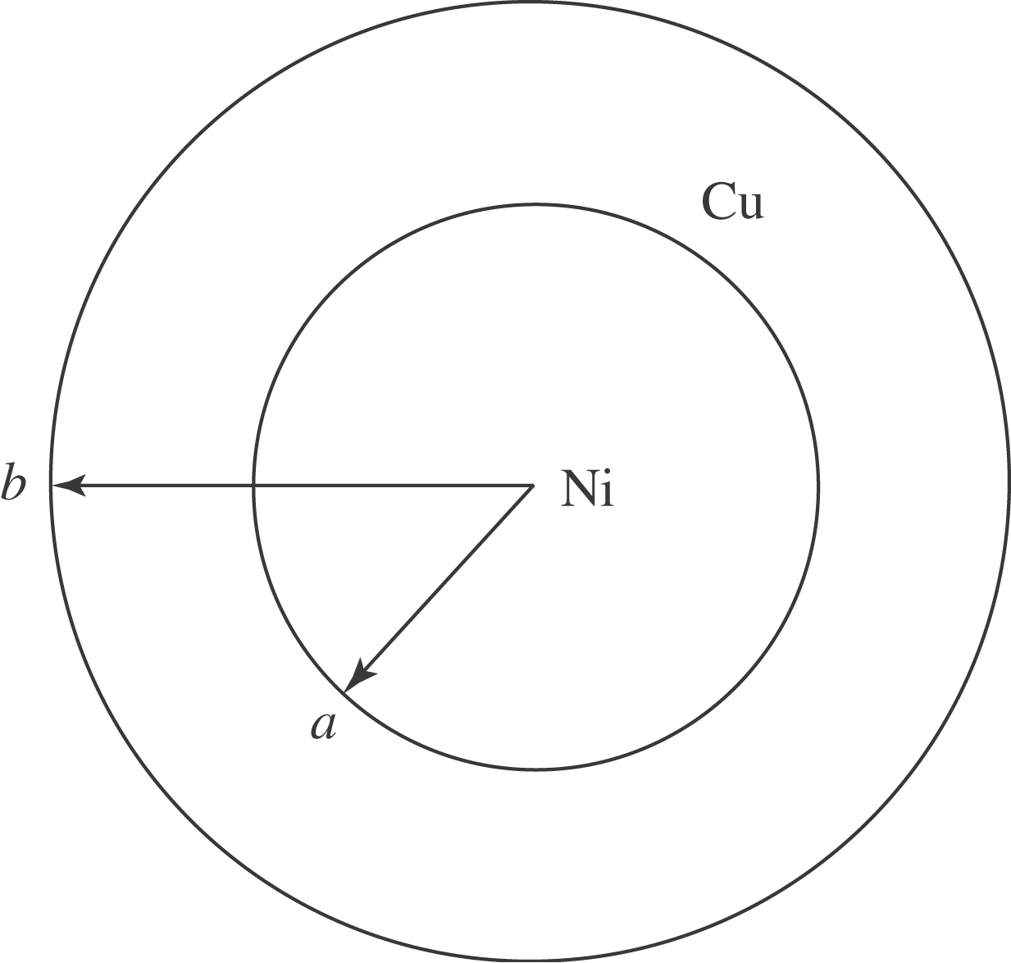
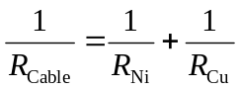
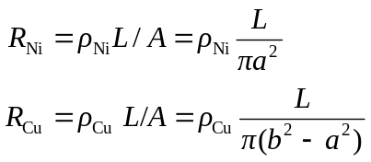

So: 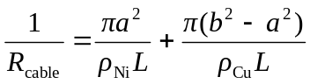
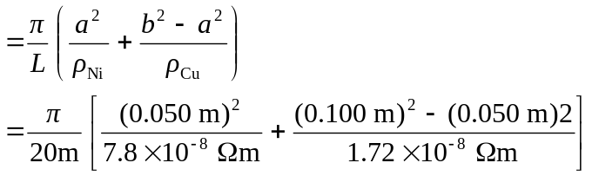
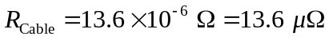
b) 